

**Project Document**

**Name :S Saravana kumar**

**Register Number :720722110021**

**Department : B.Tech IT**

**Year : 2nd year**

**Project Title**

Design Thinking In Amazon

**Template Name**

Stratergy Blueprint

**Problem Statement**

The shopping experience has gradually gotten worse over time, where it’s difficult to navigate, presents too many choices, and lacks any intelligence or personalization. The challenge is that design and technology have evolved extensively in the last 20 years and other competitors are providing better web experiences

**Project description**

**Introduction:**

**The project aims to implement design thinking principles within Amazon's strategic blueprint, fostering innovation, customer-centricity, and agility in decision-making processes. By integrating design thinking methodologies into strategic planning, Amazon can enhance its competitive edge, adaptability, and customer satisfaction.**

**Objectives:**

**Infuse design thinking principles into Amazon's strategic framework.**

**Cultivate a culture of innovation and customer empathy across all departments.**

**Identify and prioritize customer pain points and opportunities for enhancement.**

**Streamline product/service development processes for increased efficiency and effectiveness.**

**Enhance Amazon's ability to anticipate and respond to market trends and customer demands.**

**Key Components:**

**a. Empathy Mapping and User Research:**

**Conduct in-depth research to understand customers' needs, behaviors, and pain points. Utilize empathy mapping techniques to gain insights into customers' emotions, desires, and motivations.**

**b. Ideation Workshops:**

**Facilitate brainstorming sessions and ideation workshops involving cross-functional teams. Encourage diverse perspectives and creative thinking to generate innovative solutions to identified challenges.**

**c. Prototyping and Testing:**

**Develop rapid prototypes of potential solutions based on the ideas generated during ideation sessions. Conduct user testing and feedback sessions to validate prototypes and iterate on designs based on user insights.**

**d. Iterative Design Process:**

**Implement an iterative design process that emphasizes continuous improvement and iteration based on user feedback and real-world testing results. Foster a mindset of experimentation and learning from failures.**

**. Implementation Roadmap:**

**Develop a detailed implementation roadmap outlining the steps, timelines, and responsible stakeholders for integrating design thinking into Amazon's strategic planning process. Identify key metrics to track the success and impact of the initiative.**

**g. Training and Skill Development:**

**Provide training and skill development programs to equip employees with the tools, techniques, and mindset required to apply design thinking principles effectively in their work.**

**Outcomes:**

**Enhanced customer satisfaction and loyalty through the delivery of innovative products and services that address genuine customer needs.**

**Increased efficiency and effectiveness in strategic decision-making processes, resulting in faster time-to-market and improved ROI.**

**A culture of creativity, collaboration, and continuous improvement embedded within the organization.**

**Risk Management:**

**Identify potential risks and challenges associated with implementing design thinking within Amazon's organizational structure.**

**Develop mitigation strategies to address these risks and minimize their impact on the project's success.**

**Regularly monitor and reassess risks throughout the project lifecycle.**

**Conclusion:**

**By embracing design thinking principles and integrating them into its strategic blueprint, Amazon can foster a culture of innovation, customer-centricity, and agility that drives sustainable growth and competitive advantage in today's dynamic marketplace. This project serves as a roadmap for leveraging design thinking to unlock new opportunities and deliver exceptional value to customers, employees, and shareholders alike.**

**Worked Template with explanation**

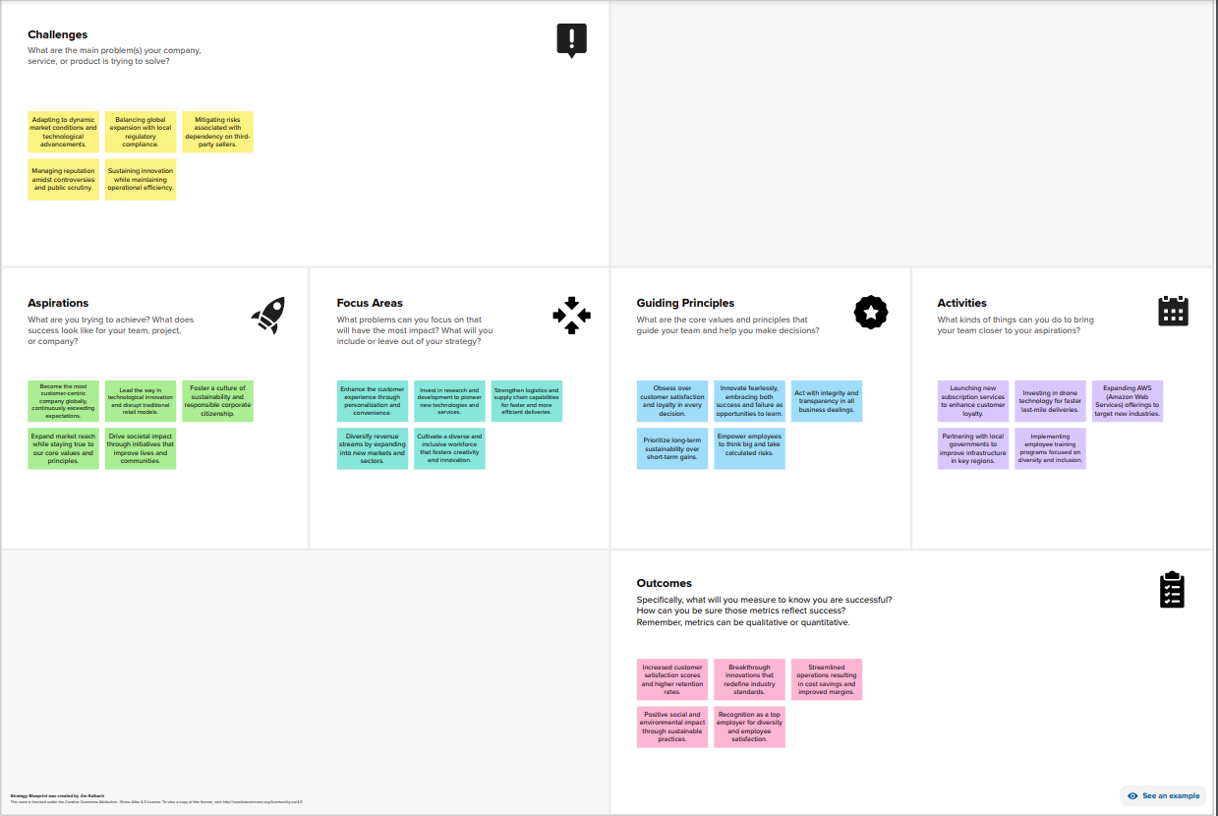

**GitHub Link:**